**BitPresent - Documentation**

**Current Version: v1.3.1**

**Table of Contents**

Introduction - - - - - - - - - - - - - - 1

Basic Usage - - - - - - - - - - - - - - 1

Basic Elements - - - - - - - - - - - - - - 1

Slide Types - - - - - - - - - - - - - - 2

Title Slide - - - - - - - - - - - - - 2

Generic Slide - - - - - - - - - - - - - 2

Image Slide - - - - - - - - - - - - - 3

Dot Commands - - - - - - - - - - - - - - 3

Background - - - - - - - - - - - - - 3

Font - - - - - - - - - - - - - 3

Text Color - - - - - - - - - - - - - 4

Image - - - - - - - - - - - - - 4

Notes - - - - - - - - - - - - - - 4

License - - - - - - - - - - - - - - 4

**Introduction**

This Document includes usage, basic concepts and details about BitPresent. First of all, what is BitPresent? BitPresent is a minimalistic presentation creating application, which uses a Markdown styled text input format and generates a PDF Document, which will be dieplayed in fullscreen, when using any other popular PDF Viewer than the one built into your web browser. BitPresent supports a variety of things, which can also be found in this document.

**Basic Usage**

Upon startup of the application, you will be greeted with a blank screen.

The field on the left is the editing field. Like the name suggest, you edit your presentation in that area. In the top right, there is your preview. It displays a preview of the slide in the current context, eg. the slide that you are currently editing. It will be blank at first, since there is no side to preview yet. In the bottom right will be displayed any errors or warnings, for example when you try to open an image that does not exist, it will report it to you there.

You can insert slides, images, subpoints, subtitles and dot commands through the insert menu. Each of the listed elements are in their respecting category in this document.

**Basic Elements**

Basic elements are points, subpoints and subtitles. After you have inserted a slide wither by typing or using the menu, you can insert points just by typing them without any prefix. A subpoint is a point refering to another point and can be inserted either via the insert menu, or by prefixing the text with an asterisk symbol (*)(for example: * This is a subpoint)

Note that points and subpoints can not exist on any slide. More on that can be found in the “Slide Types“ section. Subtitles can be created either by, once again, using the menu or by surrounding the Text with dashes (-)

(for example: -This is a Subtitle-)

Each basic element has to be in a slide context, which means, that at least one slide has to be created. The editor will give a warning, if a basic element is defined outside of a slide.

**Slide Types**

***Title Slide***

A title slide consists out of a title and a subtitle. It cannot have any images, points or subpoints. This slide is useful for, like the name suggests, a title slide or an ending slide. To define a title slide, surround the title of the slide with smaller then and greater then symbols(< and >) or use the insert menu.

Example:

<My Topic>

-This is a Title Slide-

Results in:

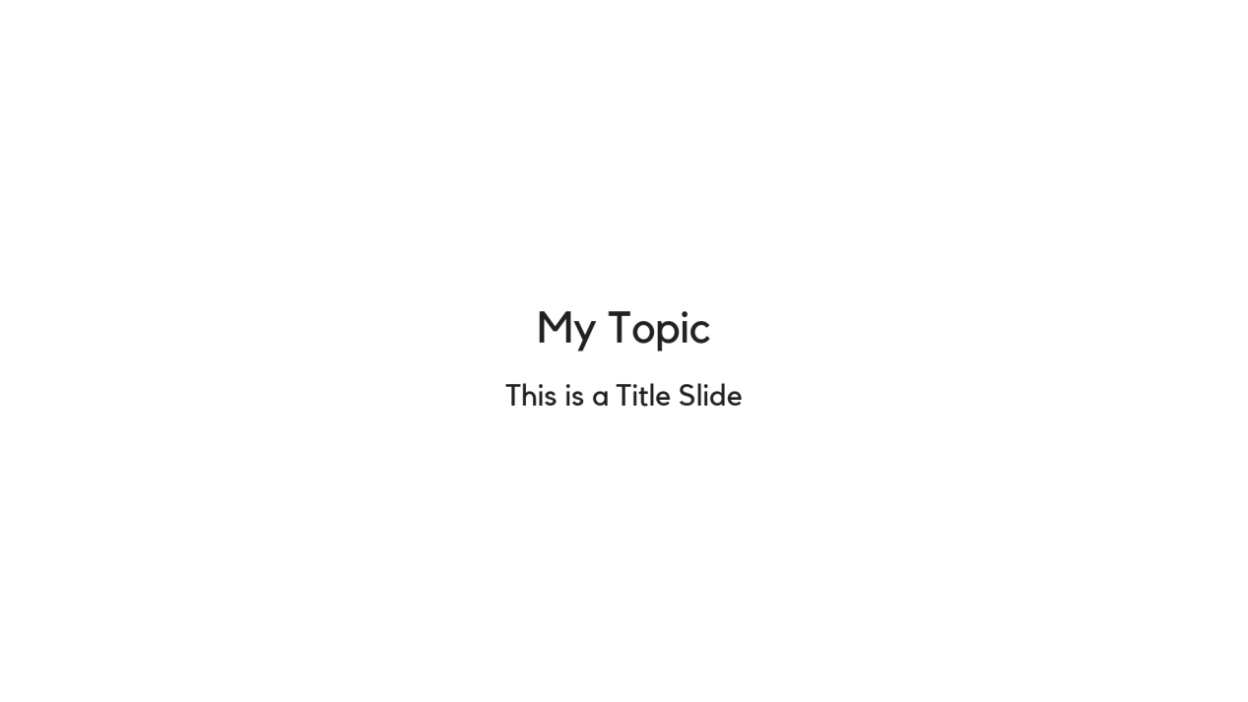

***Generic Slides***

A generic slide can hold any element available, like basic elements or an image. To define one, surround the title of the slide with square brackets ([ and ]), or use the insert menu. Each slide is limited to 1 image only.

Example:

[My Slide]

-This is a Generic Slide-

This can hold points

* And subpoints!

Results in:



***Image Slide***

An image slide has the same layout as the generic slide. It is also defined almost like a generic slide. You specify the title and / or the subtitle, specify an image with the corresponding dot command, but don‘t specify any points or subpoints. This will lead to having the image scaled bigger, if possible, than it would have been on a generic slide.

**Dot Commands**

***Background***

This dot command specifies the background image for the whole presentation. If it is specified multiple times, the last definition will be used. This command is preferred to be specified at the beginning of the presentation, before any slide is defined. It can be defined manually with the syntax below, or with the insert menu. When using the menu, the selected image will be copied to a temporary location, if the presentation is not saved yet, or if it is saved already to the “Images“ folder in the same directory as the .txt file.

Syntax:

.background <image>

Where <image> is replaced with either “default“ or the path to the image, which can either be relative or absolute.

***Font***

This command specifies the font for the whole presentation. If it is specified multiple times, the last definition will be used. This command is preferred to be specified at the beginning of the presentation, before any slide is defined. It can be defined manually with the syntax below, or with the insert menu. When using the menu, the selected font file will be copied to a temporary location, if the presentation is not saved yet, or if it is saved already to the “Fonts“ folder in the same directory as the .txt file.

Syntax:

.font <font_file>

Where <font_file> is replaced with either “default“ or the path to the font file, which can either be relative or absolute.

***Text Color***

This command specifies the text color for the whole presentation. If it is specified multiple times, the last definition will be used. This command is preferred to be specified at the beginning of the presentation, before any slide is defined. It can be defined manually with the syntax below, or with the insert menu.

Syntax:

.color <colorcode>

Where <colorcode> is replaced with either “default“ or a hexadecimal color code without any prefixes, for example: .color CE3142

***Image***

This command specifies the image to be displayed on the current slide, which means that this has to be used in a slide context. It can be defined manually with the syntax below, or with the insert menu. When using the menu, the selected image will be copied to a temporary location, if the presentation is not saved yet, or if it is saved already to the “Images“ folder in the same directory as the .txt file. Each slide is limited to 1 imge only. If defined multiple times in the same slide, the last definition will be used.

Syntax:

.image <image>

Where <image> is replaced with either “default“ or “none“ for no image, or the path to the image, which can either be relative or absolute.

**Notes**

This application was developed by a single developer, namely BitTim.

Future releases are planned to have plug-in support.

I appreciate it if you decide to use this application. Huge thank you if that is the case!

**License**

This application is licensed under GPL3, which can be found here:

<https://www.gnu.org/licenses/gpl-3.0.en.html>